**CS509 Design of Software Systems**

# Project Task 1

# WordCombination: Storyboards

Version: 1.1

# **Brief Introduction**

As client, we introduce details of storyboard of game WordCombination in details by showing several GUIs with players.

First, players open the client and login . Once login is successful, a list of available games is shown in board, with information like how many players are in a specific game. Then the players can choose one of games to join or start a new game as a manager, also if the player is not familiar with the game, he/she can choose practice model. Once he/she makes a decision, different types of game windows will show up. In game window, there are several letters which the player can choose to combine, and he/she can see the game score. After submitting the letters he/she chooses, the score will change. Also, if there are more players in a same game, there will be a box to indicate which letters are shared among players. In multiple players model, scores of each player is public to everyone, and manager of this game can choose to restart game so everyone’s score is 0 and letter board will refresh, and if the manager locks the game, then no one can join this game.

In the following part, we will describe in detail the user interfaces that the player is likely to use when executing each of the aforementioned functionalities.

# Use Case: Login

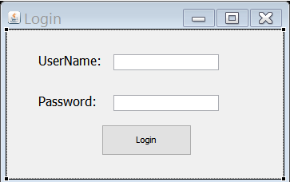

After user *login*, the client will show up

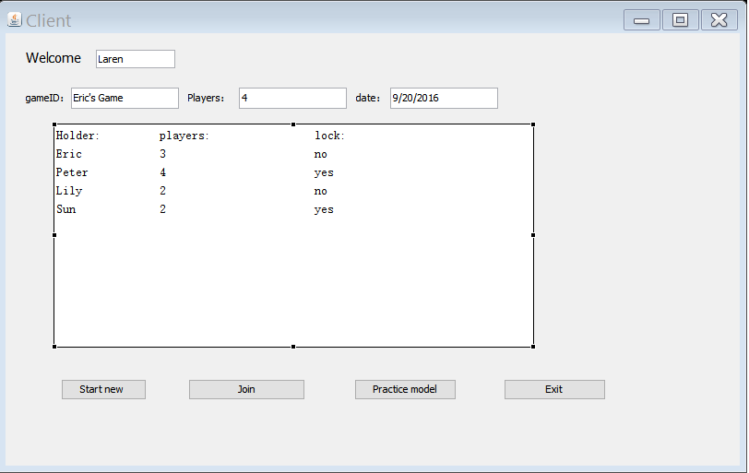

There a board showing games list with information like holder name and number of players and whether each game is lock or not.

# Use Case: Start new game

If the player wants to *start a new game*, hit start new button, then manger game window will show up with information like statue of game(lock or unlock). After manger invite friends, player1,2,3,4 will automatically change to friends’ name.

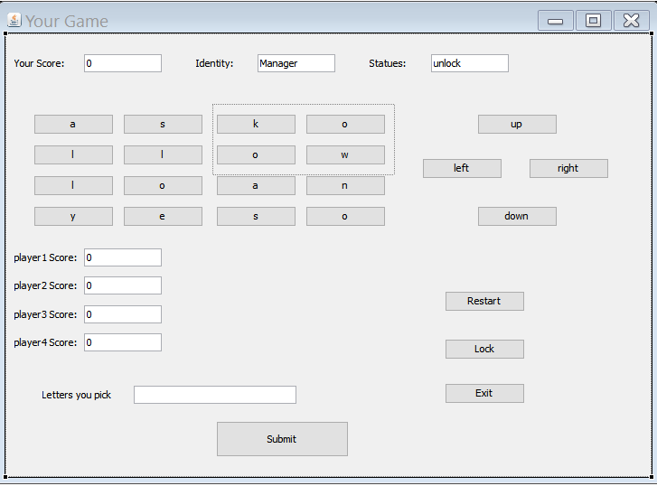

# Use Case:Practice

If the player hits *practice model* button, then practice model game window opens.

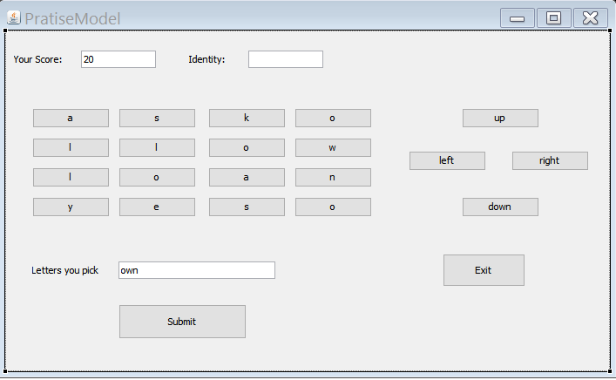

# Use Case:Join game

If the player choose to *join* a friends game, join window will show up to verify whether he/she gets permission to access to the game or not by verifying password. If the player does not want to join, he/she can exit by hitting *X*.

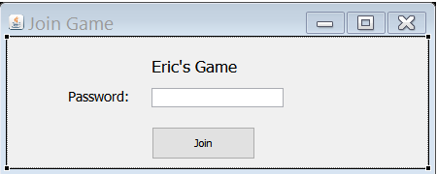

# Use Case:New player join and game restart

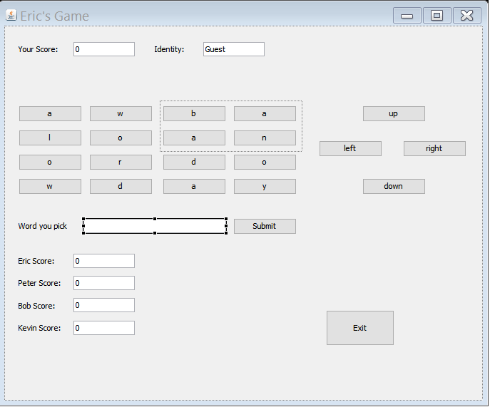

After verification, multiple player game window opens and current game will restart. Information contains players’ names and score and which letters are shared and which letters she/he has chosen.

# Use Case:choose letters

The player can choose letters to form a word by hitting buttons which a contain letter, then the letters will appear in *World you pick* box.

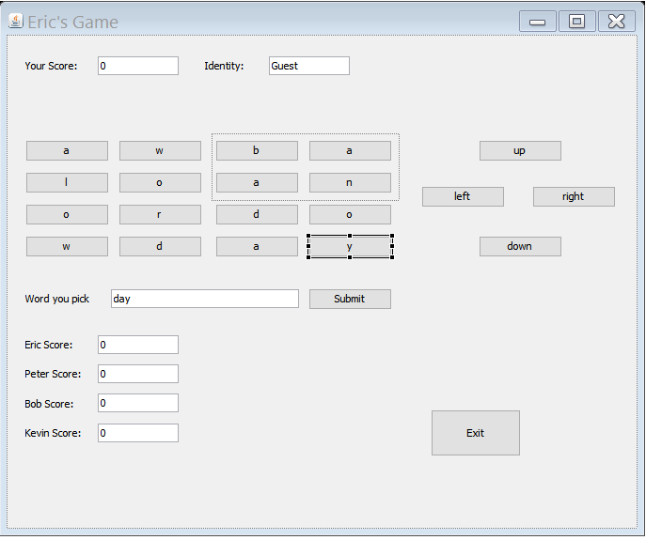

# Use Case:Move letters Box

If the player want to change letters in the field , he/she can hit *up/left/right/down* to move filed and get a different row/column of letters. For example, if he/she hit *left* button, the left most column will disappear, and a new column of letters will show up in right most of game field. And shared box will not change.

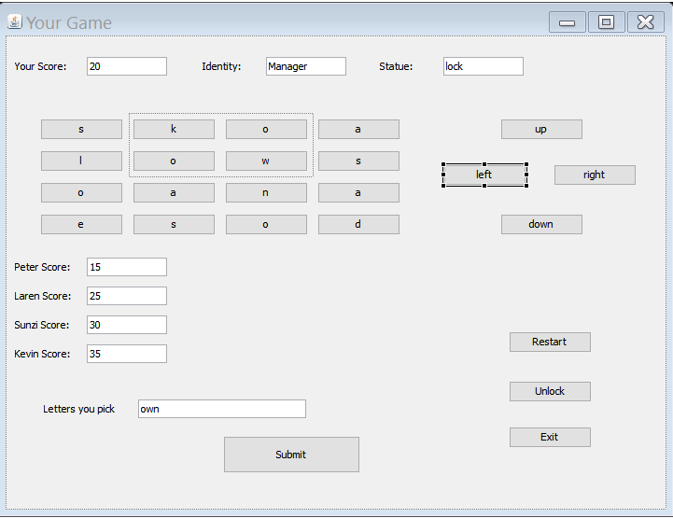

# Use Case:submit letters

if the player thinks the letters chosen can form a word, he/she can submit and gain score by hitting button *Submit.* If correct, his/her score will increase.

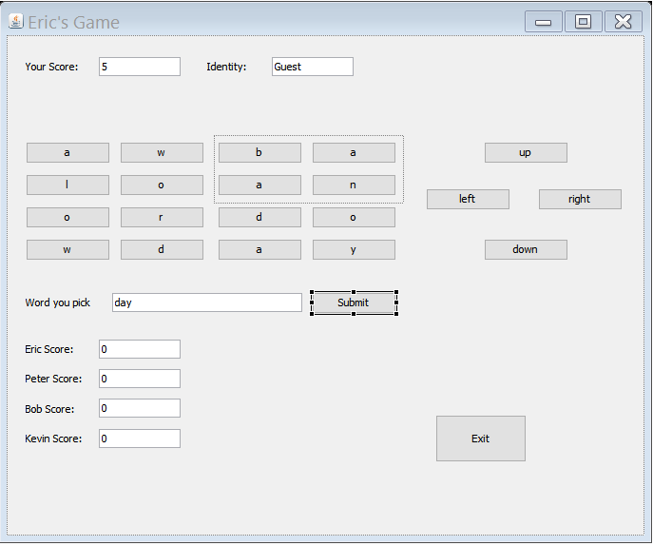

# Use Case:undo letters

if the player find the letters chosen not right, he/she can back by hitting the last letter, then the last letter will disappear in *World you pick* box.

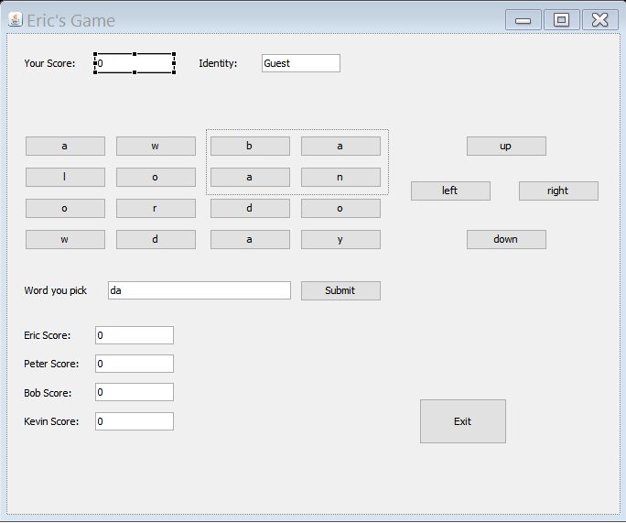

# Use Case: Manger exit multiple players game

Any players can exit game at any time by hitting Exit button, however, if the manager exit, the first player to join the game will automatically become manger, who is able to restart or lock game. For example, if Eric exits game, then Laren become manager, and players score will not change. The first figure is Eric’s GUI, the second is Laren’s GUI before Eric exits, the third is Laren’s GUI after Eric exits and Laren becomes manager.

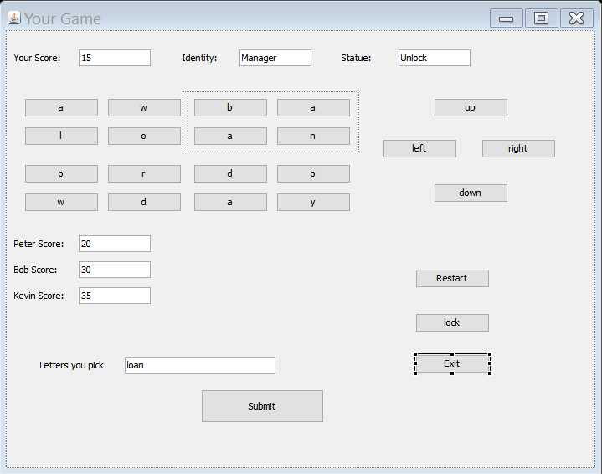

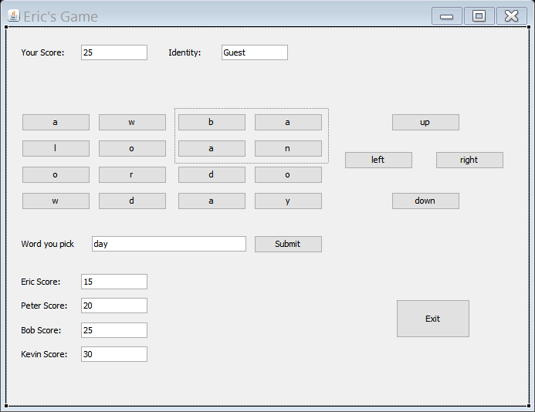

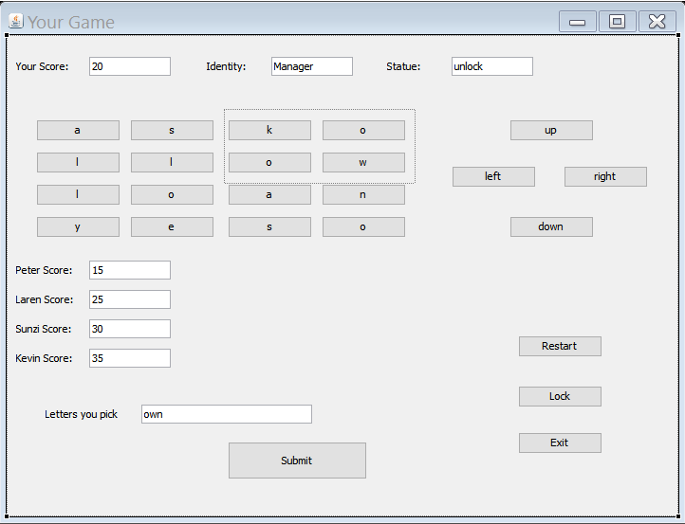

# Use Case: Manger Lock game

After Laren becomes manger, she does not want others to join game even some people were told the password, so she locks game by hitting *Lock button*.Then *Statue* of the game is Lock and *Lock* button becomes *Unlock* button.

